ADA Lab

Assignment - 8

Dated: 31-03-2021

Sub Code: CSE-228

**Jeesu Jain**

**191112203**

**CSE - 2**

Department of

Computer Science and Engineering

Subject Coordinator:

Prof. Manish Pandey



**Maulana Azad**

**National Institute of Technology,**

**BHOPAL – 462 003 (INDIA)**

Contents

Problem 1: 0-1 Graph BFS DFS 2

Code 2

Output 3

Analysis 4

# Problem 1: Grapg BFS DFS

## Design, Develop and Implement a Program in your preferred language for the following operations on Graph(G) of Cities (Take graph of your choice)

## a) Create a Graph of N cities using Adjacency Matrix.

## b) Print all the nodes reachable from a given starting node in a digraph using BFS method.

## c) Check whether a given graph is connected or not using DFS method

## Code

#include <iostream>

using namespace std;

class Graph {

   public:

    bool** adjMatrix;

    int numVertices;

  // Initialize the matrix to zero

  Graph(int numVertices) {

    this->numVertices = numVertices;

    adjMatrix = new bool*[numVertices];

    for (int i = 0; i < numVertices; i++) {

      adjMatrix[i] = new bool[numVertices];

      for (int j = 0; j < numVertices; j++)

        adjMatrix[i][j] = false;

    }

  }

  void addEdge(int i, int j) {

    adjMatrix[i][j] = true;

    adjMatrix[j][i] = true;

  }

  void bfs(int vertex){

    int reach[numVertices];

    bool vis[numVertices];

    for(int i=0 ;   i<numVertices   ;   i++){

        reach[i] = -1;

        vis[i] = false;

    }

    int start=0,end=0;

    reach[start] = vertex;

    vis[vertex] = true;

    while(start<=end){

        int u = reach[start];

        start++;

        for(int i=0 ;   i<numVertices   ;   i++){

            if(vis[i] == false && adjMatrix[u][i] == true){

                reach[++end] = i;

                vis[i] = true;

            }

        }

    }

    cout << "vertex reachable from vertex " << vertex <<" are : ";

    for(int i=1 ;   i<=end  ;   i++){

        cout << reach[i] <<" ";

    }

  }

  void dfs(int vertex,bool vis[],int & cnt){

    vis[vertex] = true;

    cnt++;

    for(int i=0 ;   i<numVertices   ;   i++){

        if(vis[i] == false && adjMatrix[vertex][i] == true){

            dfs(i,vis,cnt);

        }

    }

  }

  void connected(){

    bool vis[numVertices];

    for(int i=0 ;   i<numVertices   ;   i++){

        vis[i] = false;

    }

    int cnt=0;

    dfs(0,vis,cnt);

    if(cnt == numVertices){

        cout << "\nGraph is connected\n";

    }

    else{

        cout << "\nGraph is not connected\n";

    }

  }

};

int main() {

  Graph g(6);

    g.addEdge(0, 1);

    g.addEdge(1, 2);

    g.addEdge(4, 0);

    g.addEdge(4, 1);

    g.addEdge(2, 3);

    g.addEdge(3, 1);

    g.addEdge(3, 5);

    g.bfs(0);

    g.connected();

}

## Output

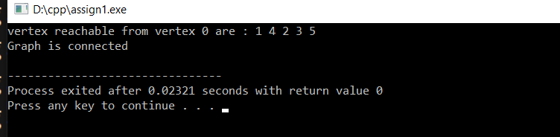

## Analysis

**Time Complexity**: O(N).

For BFS/DFS

**Auxiliary Space**: O(N*N).

For storing adjacency matrix